**Institut Sains Terapan dan Teknologi Surabaya**

Jl. Ngagel Jaya Tengah 73 - 77, Surabaya 60284

Telp. (031) 5027920 Fax. (031) 5041509

Laboratorium : E-401 Praktikum : Pemrograman Client Server

Waktu : Senin / 10.45 – 12.45 Jurusan : S1 – Teknik Informatika

Minggu Ke : 1 Tanggal : -

Materi : Advance Query Jenis Soal : Materi dan Tugas

**MATERI (TOTAL = 40)**

Berdasarkan database yang diberikan, rangkailah query untuk menghasilkan output yang diminta

1. Tampilkan nama agen yang memiliki minimal 1 client player dan 1 client manager. Tampilkan pula jumlah client dan manager mereka.

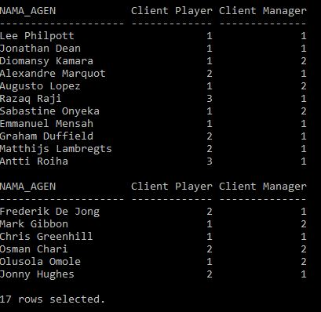

1. Tampilkan nama setiap manager yang terdaftar beserta agen yang bekerja untuk manager tersebut. Jika manager tidak memiliki agen, maka beri keterangan bahwa manager tidak memiliki agen.

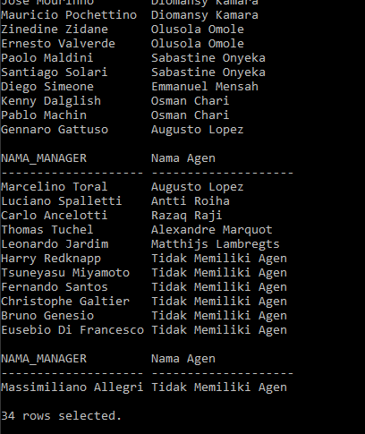

1. Tampilkan semua kombinasi dari nama agen, pemain yang menjadi klien agen, dan manager yang menjadi klien agen dimana tidak boleh ada kolom yang kosong yang ditampilkan.

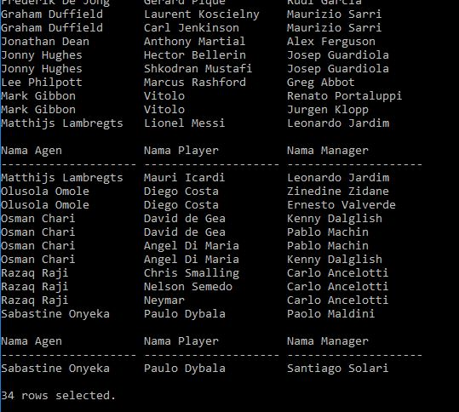

1. Tampilkan negara, tampilkan juga stadion terbesar yang ada di negara tersebut beserta kapasistasnya. Yang perlu ditampilkan hanya negara yang memiliki stadion yang tercatat pada database.

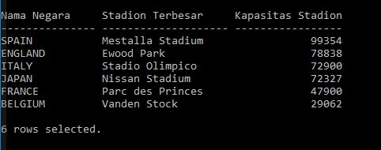

**Catatan : Pengerjaan harus dilakukan dengan sempurna, termasuk header. Jika header kolom berbeda atau urutan data tidak sama dengan contoh, maka jawaban pada nomor yang bersangkutan akan di**

**div 2!**

**MATERI : 40**

|  |  |
| --- | --- |
| SCORE | KRITERIA |
| Insert | |
| 15/7/0 | Mengerjakan nomor 1 dengan benar |
| 10/5/0 | Mengerjakan nomor 2 dengan benar |
| 5/2/0 | Mengerjakan nomor 3 dengan benar |
| 10/5/0 | Mengerjakan nomor 4 dengan benar |
| Total : 40 | |

**TUGAS : 30**

Sesuai dengan database yang diberikan, rangkailah query yang akan menghasilkan output sebagai berikut

1. Tampilkan nama club yang beraktivitas di pasar pemain (bertransaksi) selama 3 tahun berturut-turut di antara tahun 2012 – 2018. Contoh: (2012-2014 atau 2013-2015 atau 2014-2016, dst). Lalu urutkan data agar secara descending berdasarkan **huruf ke-dua** dari nama club.

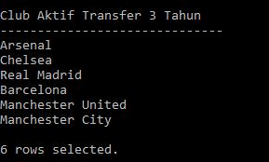

1. Tampilkan nama negara dan stadion terbesar yang ada di negara tersebut. Tampilkan juga **kapasitas stadion rata-rata pada negara tersebut.**

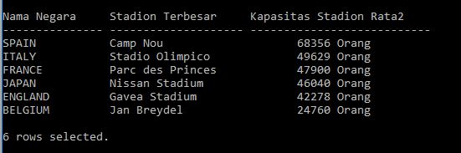

1. Tampilkan nama semua manager yang terdaftar pada database beserta club tempat mereka bekerja. Jika mereka tidak bekerja untuk sebuah club, maka biarkan kolom club kosong.

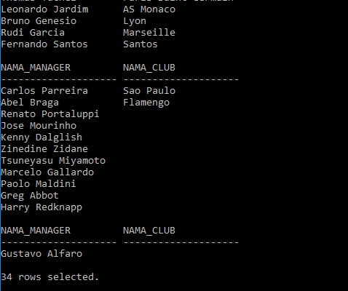

1. Tampilkan nama player yang memiliki total harga transaksi lebih dari 50.000.000, dan dijual lebih dari 1 kali, dan juga memiliki rata-rata penjualan diatas 30.000.000. Lalu jika negara asal pemain tersebut mengandung huruf ‘B’, maka buatlah nama pemain tersebut tampil menjorok ke kanan.

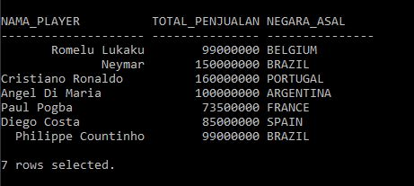

**Catatan : Pengerjaan harus dilakukan dengan sempurna, termasuk header. Jika header kolom berbeda atau urutan data tidak sama dengan contoh, maka jawaban pada nomor yang bersangkutan akan dinilai 0!**

**KRITERIA YANG TIDAK DI HIGHLIGHT TIDAK AKAN DIPERIKSA**

|  |  |
| --- | --- |
| SCORE | KRITERIA |
| 5/0 | Mengerjakan nomor 1 dengan benar |
| 5/0 | Mengerjakan nomor 2 dengan benar |
| 10/0 | Mengerjakan nomor 3 dengan benar |
| 10/0 | Mengerjakan nomor 4 dengan benar |
| Total : 30 | |

Menyetujui Mengetahui Penyusun Soal

(Riandika Lumaris, S.Kom., M.Kom.) (Grace Levina Dewi, M.Kom.) (Kenny Vincent)

Koordinator Kuliah Koordinator Laboratorium Asisten

|  |  |
| --- | --- |
| Negara | |
| column | type |
| id_negara | Varchar2(3), PK |
| Nama_negara | Varchar2(15) |

|  |  |
| --- | --- |
| Liga | |
| column | type |
| id_liga | Varchar2(5), PK |
| Nama_liga | Varchar2(30) |
| Id_negara | Varchar2(3), references negara(id_negara) |
| divisi | number |

|  |  |
| --- | --- |
| Agen | |
| column | type |
| id_agen | Varchar2(7), PK |
| Nama_agen | Varchar2(20) |
| experience | Number |
| Id_negara | Varchar2(3), references negara(id_negara) |

|  |  |
| --- | --- |
| Manager | |
| column | type |
| id_manager | Varchar2(6), PK |
| Nama_manager | Varchar2(20) |
| Dob_manager | date |
| Id_negara | Varchar2(3), references negara(id_negara) |
| Id_agen | Varchar2(7), references agen(id_agen) |

|  |  |
| --- | --- |
| Club | |
| column | type |
| id_club | Varchar2(7), PK |
| Nama_club | Varchar2(20) |
| Tahun_berdiri | date |
| Id_liga | Varchar2(5), references liga(id_liga) |

|  |  |
| --- | --- |
| Stadium | |
| column | type |
| id_stadium | Varchar2(6), PK |
| Nama_stadium | Varchar2(20) |
| Kapasitas | Number |
| Id_club | Varchar2(7), references club(id_club) |
| Id_negara | Varchar2(3), references negara(id_negara) |

|  |  |
| --- | --- |
| Player | |
| column | type |
| id_player | Varchar2(8), PK |
| Nama_player | Varchar2(20) |
| Dob_player | Date |
| Id_club | Varchar2(7), references club(id_club) |
| Id_negara | Varchar2(3), references negara(id_negara) |
| Id_agen | Varchar2(3), references agen(id_agen) |

|  |  |
| --- | --- |
| H_transaksi | |
| column | type |
| id_transaksi | Varchar2(8), PK |
| Club_asal | Varchar2(7), references club(id_club) |
| Club_baru | Varchar2(7), references club(id_club) |
| Biaya_transfer | Number |
| Tgl_transfer | Number |

|  |  |
| --- | --- |
| D_transaksi | |
| column | type |
| id_transaksi | Varchar2(8), PK |
| Id_player | Varchar2(8), references player(id_player), PK |
| Subtotal | Number |

|  |  |
| --- | --- |
| Club_Manager | |
| column | type |
| id_club | Varchar2(7), references club(id_club), PK |
| Id_manager | Varchar2(6), references manager(id_manager), PK |

|  |  |
| --- | --- |
| Negara | |
| id_negara | nama_negara |
| ENG | ENGLAND |
| FRN | FRANCE |
| ESP | SPAIN |
| WLS | WALES |
| GER | GERMANY |
| ITA | ITALY |
| JPN | JAPAN |
| ROM | ROMANIA |
| RUS | RUSSIA |
| UKR | UKRAINE |
| BEL | BELGIUM |
| HOL | HOLLAND |
| USA | USA |
| SWE | SWEDEN |
| NOR | NORWAY |
| CRO | CROATIA |
| ICE | ICELAND |
| DEN | DENMARK |
| CZE | CZECH |
| IRE | IRELAND |
| FIN | FINLAND |
| BUL | BULGARIA |
| SER | SERBIA |
| KOR | SOUTH KOREA |
| ARG | ARGENTINA |
| BRA | BRAZIL |
| POR | PORTUGAL |
| SCO | SCOTLAND |

|  |  |  |  |
| --- | --- | --- | --- |
| Liga | | | |
| id_liga | nama_liga | id_negara | divis |
| EN001 | Premier League | ENG | 1 |
| EN002 | EFL Championship | ENG | 2 |
| EN003 | English Football League | ENG | 3 |
| EN004 | EFL League One | ENG | 4 |
| EN005 | EFL League Two | ENG | 5 |
| EN006 | National League (division) | ENG | 6 |
| FR001 | [Ligue 1](https://en.wikipedia.org/wiki/Ligue_1) | FRN | 1 |
| FR002 | [Ligue 2](https://en.wikipedia.org/wiki/Ligue_2) | FRN | 2 |
| FR003 | [Championnat National](https://en.wikipedia.org/wiki/Championnat_National) | FRN | 3 |
| FR004 | [Championnat National 2](https://en.wikipedia.org/wiki/Championnat_National_2) | FRN | 4 |
| FR005 | [Championnat National 3](https://en.wikipedia.org/wiki/Championnat_National_3) | FRN | 5 |
| SP001 | [La Liga](https://en.wikipedia.org/wiki/La_Liga) | ESP | 1 |
| SP002 | [Segunda División](https://en.wikipedia.org/wiki/Segunda_Divisi%C3%B3n) | ESP | 2 |
| SP003 | [Segunda División B](https://en.wikipedia.org/wiki/Segunda_Divisi%C3%B3n_B) | ESP | 3 |
| SP004 | [Tercera División](https://en.wikipedia.org/wiki/Tercera_Divisi%C3%B3n) | ESP | 4 |
| SP005 | [Divisiones Regionales de Fútbol](https://en.wikipedia.org/wiki/Divisiones_Regionales_de_F%C3%BAtbol) | ESP | 5 |
| IT001 | [Serie A](https://en.wikipedia.org/wiki/Serie_A) | ITA | 1 |
| IT002 | [Serie B](https://en.wikipedia.org/wiki/Serie_B) | ITA | 2 |
| IT003 | [Serie C](https://en.wikipedia.org/wiki/Serie_C) | ITA | 3 |
| IT004 | [Serie D](https://en.wikipedia.org/wiki/Serie_D) | ITA | 4 |
| IT005 | [Eccellenza](https://en.wikipedia.org/wiki/Eccellenza) | ITA | 5 |
| IT006 | [Promozione](https://en.wikipedia.org/wiki/Promozione) | ITA | 6 |
| HO001 | Eredvisie | HOL | 1 |
| BA001 | Campeonato Serie A | BRA | 1 |
| AR001 | Superliga Argentina | ARG | 1 |
| US001 | Major League Soccer | USA | 1 |
| JP001 | Japan League | JPN | 1 |
| KO001 | Korea League | KOR | 1 |
| BE001 | Belgian First Division A | BEL | 1 |

|  |  |  |  |  |
| --- | --- | --- | --- | --- |
| Club | | | | |
| Id_club | Nama_club | tahun_berdiri | Id_pelatih | Id_liga |
| MU001 | Manchester United | 1878 | MAN002 | EN001 |
| AR001 | Arsenal | 1886 | MAN003 | EN001 |
| MC001 | Manchester City | 1880 | MAN004 | EN001 |
| CH001 | Chelsea | 1905 | MAN005 | EN001 |
| LI001 | Liverpool | 1892 | MAN006 | EN001 |
| TO001 | Tottenham | 1882 | MAN007 | EN001 |
| BA001 | Barcelona | 1899 | MAN008 | SP001 |
| RM001 | Real Madrid | 1902 | MAN009 | SP001 |
| AT001 | Atletico Madrid | 1903 | MAN010 | SP001 |
| SE001 | Sevilla | 1890 | MAN011 | SP001 |
| VA001 | Valencia | 1919 | MAN012 | SP001 |
| JU001 | Juventus | 1897 | MAN013 | IT001 |
| AM002 | AC Milan | 1899 | MAN014 | IT001 |
| IM001 | Inter Milan | 1908 | MAN015 | IT001 |
| NA001 | Napoli | 1926 | MAN016 | IT001 |
| AR002 | AS Roma | 1927 | MAN017 | IT001 |
| PS001 | Paris Saint Germain | 1970 | MAN018 | FR001 |
| AM001 | AS Monaco | 1919 | MAN019 | FR001 |
| LY001 | Lyon | 1950 | MAN020 | FR001 |
| LI001 | Lille | 1944 | MAN021 | FR001 |
| MA001 | Marseille | 1899 | MAN022 | FR001 |
| SA001 | Santos | 1912 | MAN023 | BA001 |
| SP001 | Sao Paulo | 1930 | MAN024 | BA001 |
| FL001 | Flamengo | 1895 | MAN025 | BA001 |
| IN001 | Internacional | 1909 |  | BA001 |
| GR001 | Gremio | 1903 |  | BA001 |
| BJ001 | Boca Junior | 1905 |  | AR001 |
| RP001 | River Plate | 1901 |  | AR001 |
| IN002 | Independiate | 1958 |  | AR001 |
| RC001 | Racing Club | 1903 |  | AR001 |
| GO001 | Gamba Osaka | 1980 |  | JP001 |
| FT001 | FC Tokyo | 1935 |  | JP001 |
| CO001 | Cerezo Osaka | 1957 |  | JP001 |
| VK001 | Vissel Kobe | 1966 |  | JP001 |
| UR001 | Urawa Reds | 1950 |  | JP001 |
| YF001 | Yokohama FM | 1972 |  | JP001 |
| GE001 | Genk | 1923 |  | BE001 |
| CB001 | Club Brugge | 1891 |  | BE001 |
| AN001 | Anderlecht | 1908 |  | BE001 |
| AV001 | [Aston Villa](http://www.bbc.co.uk/sport/football/teams/aston-villa) | 1910 |  | EN002 |
| BC001 | [Birmingham City](http://www.bbc.co.uk/sport/football/teams/birmingham-city) | 1912 |  | EN002 |
| BR001 | [Blackburn Rovers](http://www.bbc.co.uk/sport/football/teams/blackburn-rovers) | 1914 |  | EN002 |
| BW001 | [Bolton Wanderers](http://www.bbc.co.uk/sport/football/teams/bolton-wanderers) | 1916 |  | EN002 |
| BR002 | [Brentford](http://www.bbc.co.uk/sport/football/teams/brentford) | 1918 |  | EN002 |
| BC002 | [Bristol City](http://www.bbc.co.uk/sport/football/teams/bristol-city) | 1919 |  | EN002 |
| AW001 | [AFC Wimbledon](http://www.bbc.co.uk/sport/football/teams/afc-wimbledon) | 1921 |  | EN003 |
| AS001 | [Accrington Stanley](http://www.bbc.co.uk/sport/football/teams/accrington-stanley) | 1923 |  | EN003 |
| BA002 | [Barnsley](http://www.bbc.co.uk/sport/football/teams/barnsley) | 1925 |  | EN003 |
| BL001 | [Blackpool](http://www.bbc.co.uk/sport/football/teams/blackpool) | 1927 |  | EN003 |
| BC003 | [Bradford City](http://www.bbc.co.uk/sport/football/teams/bradford-city) | 1929 |  | EN003 |
| BR003 | [Bristol Rovers](http://www.bbc.co.uk/sport/football/teams/bristol-rovers) | 1922 |  | EN003 |
| EV001 | [Everton](http://www.bbc.co.uk/sport/football/teams/bristol-rovers) | 1910 |  | EN001 |

|  |  |  |  |  |
| --- | --- | --- | --- | --- |
| Stadium | | | | |
| id_stadium | nama_stadium | kapasitas | id_club | id_negara |
| STD001 | Gavea Stadium | 78838 | FL001 | ENG |
| STD002 | Bloomfield Rd | 16220 | BL001 | ENG |
| STD003 | Old Trafford | 74643 | MU001 | ENG |
| STD004 | City of Manchester | 55097 | MC001 | ENG |
| STD005 | Stamford Bridge | 41631 | CH001 | ENG |
| STD006 | Anfield | 54074 | LI001 | ENG |
| STD007 | White Hart Lane | 36284 | TO001 | ENG |
| STD008 | Camp Nou | 99354 | BA001 | ESP |
| STD009 | Santiago Barnabeu | 81044 | RM001 | ESP |
| STD010 | Wanda Metropolitano | 68000 | AM002 | ESP |
| STD011 | Pizjuan Stadium | 43883 | SE001 | ESP |
| STD012 | Mestalla Stadium | 49500 | VA001 | ESP |
| STD013 | Juventus Stadium | 41507 | JU001 | ITA |
| STD014 | San Siro | 36500 | AM002 | ITA |
| STD015 | Guiseppe Meazza | 37000 | IM001 | ITA |
| STD016 | Stadio San Paolo | 60240 | NA001 | ITA |
| STD017 | Stadio Olimpico | 72900 | AR002 | ITA |
| STD018 | Parc des Princes | 47900 | PS001 | FRN |
| STD019 | Kincho Stadium | 18000 | CO001 | JPN |
| STD020 | Noevir Stadium | 30134 | VK001 | JPN |
| STD021 | Saitama Stadium | 63700 | UR001 | JPN |
| STD022 | Nissan Stadium | 72327 | YF001 | JPN |
| STD023 | Luminus Arena | 23718 | GE001 | BEL |
| STD024 | Jan Breydel | 29062 | CB001 | BEL |
| STD025 | Vanden Stock | 21500 | AN001 | BEL |
| STD026 | Villa Park | 42682 | AV001 | [ENG](http://www.bbc.co.uk/sport/football/teams/aston-villa) |
| STD027 | St Andrew's | 29409 | BC001 | [ENG](http://www.bbc.co.uk/sport/football/teams/birmingham-city) |
| STD028 | Ewood Park | 31367 | BR001 | [ENG](http://www.bbc.co.uk/sport/football/teams/blackburn-rovers) |

|  |  |  |  |
| --- | --- | --- | --- |
| Agen | | | |
| id_agen | nama_agen | exp (years) | id_negara |
| AGEN001 | Lee Philpott | 11 | ENG |
| AGEN002 | Jonathan Dean | 8 | ENG |
| AGEN003 | Chris Greenhill | 8 | ENG |
| AGEN004 | Jonny Hughes | 10 | ENG |
| AGEN005 | Graham Duffield | 2 | ENG |
| AGEN006 | Magno Vieira | 7 | ENG |
| AGEN007 | David Bosumtwe | 12 | ENG |
| AGEN008 | Adam Bouskouchi | 3 | ENG |
| AGEN009 | David Currie | 5 | ENG |
| AGEN010 | Curtis Dawes | 1 | ENG |
| AGEN011 | Frederik De Jong | 5 | ENG |
| AGEN012 | Joseph Chenwi | 2 | ENG |
| AGEN013 | Peter Bint | 4 | ENG |
| AGEN014 | Lionel Foy | 5 | ENG |
| AGEN015 | Mark Gibbon | 8 | ENG |
| AGEN016 | Diomansy Kamara | 6 | FRN |
| AGEN017 | Olusola Omole | 1 | FRN |
| AGEN018 | Sabastine Onyeka | 9 | USA |
| AGEN019 | Emmanuel Mensah | 2 | FRN |
| AGEN020 | Osman Chari | 4 | USA |
| AGEN021 | Augusto Lopez | 5 | USA |
| AGEN022 | Antti Roiha | 4 | FIN |
| AGEN023 | Razaq Raji | 4 | IRE |
| AGEN024 | Eric Darko | 3 | USA |
| AGEN025 | Alexandre Marquot | 11 | FRN |
| AGEN026 | Matthijs Lambregts | 2 | HOL |
| AGEN027 | Bo Nilsson | 8 | SWE |
| AGEN028 | Constantin Negura | 1 | ROM |
| AGEN029 | Thiery Manigone | 9 | IRE |
| AGEN030 | Adolfo Lopes | 8 | POR |

|  |  |  |  |  |  |
| --- | --- | --- | --- | --- | --- |
| Manager | | | | | |
| id_manager | nama_manager | DOB | id_negara | id_agen |  |
| MAN001 | Greg Abbot | 14-12-1963 | ENG | AGEN001 |  |
| MAN002 | Alex Ferguson | 31-12-1941 | SCO | AGEN002 |  |
| MAN003 | Arsene Wenger | 22-10-1949 | FRN | AGEN003 |  |
| MAN004 | Josep Guardiola | 18-01-1971 | ESP | AGEN004 |  |
| MAN005 | Maurizio Sarri | 10-01-1959 | ITA | AGEN005 |  |
| MAN006 | Jurgen Klopp | 16-06-1967 | GER | AGEN015 |  |
| MAN007 | Mauricio Pochettino | 02-03-1972 | ARG | AGEN016 |  |
| MAN008 | Ernesto Valverde | 09-02-1964 | ESP | AGEN017 |  |
| MAN009 | Santiago Solari | 08-10-1976 | ARG | AGEN018 |  |
| MAN010 | Diego Simeone | 28-04-1970 | ARG | AGEN019 |  |
| MAN011 | Pablo Machin | 07-04-1975 | ESP | AGEN020 |  |
| MAN012 | Marcelino Toral | 14-08-1965 | ESP | AGEN021 |  |
| MAN013 | Massimiliano Allegri | 11-08-1967 | ITA |  |  |
| MAN014 | Gennaro Gattuso | 09-01-1978 | ITA | AGEN021 |  |
| MAN015 | Luciano Spalletti | 03-07-1959 | ITA | AGEN022 |  |
| MAN016 | Carlo Ancelotti | 10-06-1959 | ITA | AGEN023 |  |
| MAN017 | Eusebio Di Francesco | 08-09-1969 | ITA |  |  |
| MAN018 | Thomas Tuchel | 29-08-1973 | ITA | AGEN025 |  |
| MAN019 | Leonardo Jardim | 01-08-1974 | POR | AGEN026 |  |
| MAN020 | Bruno Genesio | 01-09-1966 | FRN |  |  |
| MAN021 | Christophe Galtier | 23-08-1966 | FRN |  |  |
| MAN022 | Rudi Garcia | 20-02-1964 | FRN | AGEN011 |  |
| MAN023 | Fernando Santos | 10-10-1954 | POR |  |  |
| MAN024 | Carlos Parreira | 27-02-1943 | BRA | AGEN013 |  |
| MAN025 | Abel Braga | 09-01-1952 | BRA | AGEN014 |  |
| MAN026 | Renato Portaluppi | 09-09-1962 | BRA | AGEN015 |  |
| MAN027 | Gustavo Alfaro | 14-08-1962 | ARG | AGEN013 |  |
| MAN028 | Marcelo Gallardo | 18-01-1976 | ARG | AGEN014 |  |
| MAN029 | Tsuneyasu Miyamoto | 07-02-1997 | JPN |  |  |
| MAN030 | Jose Mourinho | 26-01-1963 | POR | AGEN016 |  |
| MAN031 | Zinedine Zidane | 23-06-1972 | FRN | AGEN017 |  |
| MAN032 | Paolo Maldini | 26-06-1968 | ITA | AGEN018 |  |
| MAN033 | Harry Redknapp | 02-03-1947 | ENG |  |  |
| MAN034 | Kenny Dalglish | 04-03-1951 | SCO | AGEN020 |  |

|  |  |  |  |  |  |
| --- | --- | --- | --- | --- | --- |
| Player | | | | | |
| id_player | nama_player | DOB | id_club | id_negara | id_agen |
| DD001 | David de Gea | 07-11-1990 | MU001 | ESP | AGEN020 |
| VL001 | Victor Lindelof | 17-07-1994 | MU001 | SWE | AGEN021 |
| PJ001 | Phil Jones | 21-02-1992 | MU001 | ENG | AGEN022 |
| CS001 | Chris Smalling | 22-11-1989 | MU001 | ENG | AGEN023 |
| NM001 | Nemanja Matic | 01-08-1989 | MU001 | SER | AGEN008 |
| PP001 | Paul Pogba | 15-03-1993 | MU001 | FRN | AGEN009 |
| AH001 | Ander Herrera | 14-08-1989 | MU001 | ESP | AGEN010 |
| JM001 | Juan Mata | 28-04-1988 | MU001 | ESP | AGEN011 |
| RL001 | Romelu Lukaku | 13-05-1993 | MU001 | BEL | AGEN012 |
| MR001 | Marcus Rashford | 31-10-1997 | MU001 | ENG | AGEN001 |
| AM001 | Anthony Martial | 05-12-1995 | MU001 | FRN | AGEN002 |
| PC001 | Petr Cech | 20-05-1982 | AR001 | CZE | AGEN003 |
| SM001 | Shkodran Mustafi | 17-04-1992 | AR001 | GER | AGEN004 |
| LK001 | Laurent Koscielny | 10-09-1985 | AR001 | FRN | AGEN005 |
| NM002 | Nacho Monreal | 26-02-1986 | AR001 | ESP | AGEN006 |
| HB001 | Hector Bellerin | 19-03-1995 | AR001 | ESP | AGEN004 |
| CJ001 | Carl Jenkinson | 08-02-1992 | AR001 | FIN | AGEN005 |
| AR001 | Aaron Ramsey | 26-12-1990 | AR001 | WLS | AGEN006 |
| MO001 | Mesut Ozil | 15-10-1988 | AR001 | GER | AGEN007 |
| DW001 | Danny Welbeck | 26-11-1990 | AR001 | ENG | AGEN008 |
| JC001 | Jasper Cillessen | 22-04-1989 | BA001 | HOL | AGEN009 |
| SU001 | Samuel Umtiti | 14-11-1993 | BA001 | FRN | AGEN010 |
| GP001 | Gerard Pique | 02-02-1987 | BA001 | ESP | AGEN011 |
| JA001 | Jordi Alba | 21-03-1989 | BA001 | ESP | AGEN022 |
| NS001 | Nelson Semedo | 16-11-1993 | BA001 | POR | AGEN023 |
| PC002 | Philippe Countinho | 12-06-1992 | BA001 | BRA | AGEN024 |
| OD001 | Ousmane Dembele | 15-05-1997 | BA001 | FRN | AGEN025 |
| LM001 | Lionel Messi | 24-06-1987 | BA001 | ARG | AGEN026 |
| SB001 | Sergio Busquets | 16-07-1988 | BA001 | ESP | AGEN027 |
| FL001 | Filipe Luis | 09-08-1985 | AT001 | BRA | AGEN028 |
| JU001 | Juanfran | 09-01-1985 | AT001 | ESP | AGEN029 |
| KO001 | Koke | 08-01-1992 | AT001 | ESP | AGEN030 |
| VI001 | Vitolo | 02-11-1989 | AT001 | ESP | AGEN015 |
| AG001 | Antoine Griezmann | 21-03-1991 | AT001 | FRN | AGEN016 |
| DC001 | Diego Costa | 07-10-1988 | AT001 | ESP | AGEN017 |
| PD001 | Paulo Dybala | 15-11-1993 | JU001 | ARG | AGEN018 |
| CR001 | Cristiano Ronaldo | 05-02-1985 | JU001 | POR | AGEN019 |
| MM001 | Mario Mandzukic | 21-05-1986 | JU001 | CRO | AGEN027 |
| LM002 | Luka Modric | 09-09-1985 | RM001 | CRO | AGEN028 |
| AD001 | Angel Di Maria | 14-02-1988 | PS001 | ARG | AGEN020 |
| KM001 | Kylian Mbappe | 20-12-1998 | PS001 | FRN | AGEN022 |
| NE001 | Neymar | 05-02-1992 | PS001 | BRA | AGEN023 |
| HK001 | Hiroshi Kiyotake | 12-11-1989 | CO001 | JPN | AGEN024 |
| YM001 | Yusuke Maruhasi | 02-09-1990 | CO001 | JPN | AGEN025 |
| MI001 | Mauri Icardi | 19-02-1993 | IM001 | ARG | AGEN026 |
| LI001 | Lorenzo Insigne | 04-06-1991 | NA001 | ITA | AGEN027 |
| JP001 | Javier Pastore | 20-06-1989 | AR002 | ARG | AGEN028 |
| DA001 | Dani Alves | 06-05-1983 | PS001 | BRA | AGEN029 |
| IR001 | Ivan Rakitic | 10-03-1998 | BA001 | CRO | AGEN030 |

|  |  |  |  |  |
| --- | --- | --- | --- | --- |
| Transaksi | | | | |
| id_transaksi | club_asal | club_baru | biaya_transfer | tgl_transfer |
| TRANS001 | EV001 | MU001 | 50000000 | 10-07-2017 |
| TRANS002 | JU001 | MU001 | 70000000 | 09-08-2016 |
| TRANS003 | AM001 | MU001 | 20000000 | 09-08-2017 |
| TRANS004 | NA001 | PS001 | 55000000 | 09-08-2012 |
| TRANS005 | RM001 | AR001 | 40000000 | 09-08-2016 |
| TRANS006 | MU001 | BA001 | 5500000 | 01-07-2008 |
| TRANS007 | AM001 | MU001 | 8000000 | 01-09-2015 |
| TRANS008 | CH001 | AT001 | 50000000 | 01-01-2018 |
| TRANS009 | CH001 | AT001 | 15000000 | 28-07-2015 |
| TRANS010 | LI001 | BA001 | 90000000 | 06-01-2018 |
| TRANS011 | LY001 | BA001 | 15000000 | 12-06-2016 |
| TRANS012 | TO001 | RM001 | 40000000 | 27-08-2012 |
| TRANS013 | SE001 | BA001 | 20000000 | 01-07-2014 |
| TRANS014 | CH001 | EV001 | 25000000 | 31-05-2014 |
| TRANS015 | EV001 | CH001 | 24000000 | 02-09-2014 |
| TRANS016 | IM001 | LI001 | 9000000 | 06-01-2013 |
| TRANS017 | AT001 | MU001 | 12000000 | 01-07-2011 |
| TRANS018 | SA001 | BA001 | 50000000 | 01-07-2013 |
| TRANS019 | AT001 | CH001 | 35000000 | 07-01-2014 |
| TRANS020 | MU001 | RM001 | 60000000 | 01-07-2009 |
| TRANS021 | RM001 | JU001 | 100000000 | 10-07-2018 |
| TRANS022 | CH001 | AR001 | 12000000 | 01-07-2015 |
| TRANS023 | MU001 | AR001 | 17000000 | 01-09-2014 |
| TRANS024 | VA001 | CH001 | 26000000 | 24-08-2011 |
| TRANS025 | CHO01 | MU001 | 38000000 | 24-08-2014 |
| TRANS026 | RM001 | VA001 | 1100000 | 01-07-2007 |
| TRANS027 | VA001 | BA001 | 10000000 | 01-07-2012 |
| TRANS028 | AT001 | JU001 | 20000000 | 01-07-2015 |
| TRANS029 | BA001 | AR001 | 500000 | 01-07-2011 |
| TRANS030 | RM001 | MU001 | 50000000 | 25-08-2014 |
| TRANS031 | MU001 | PS001 | 50000000 | 06-08-2015 |
| TRANS032 | PS001 | AR002 | 15000000 | 01-07-2018 |
| TRANS033 | MU001 | JU001 | 3500000 | 03-08-2012 |
| TRANS034 | BA001 | JU001 | 9000000 | 01-07-207 |
| TRANS035 | BA001 | PS001 | 106000000 | 01-08-2014 |

|  |  |  |
| --- | --- | --- |
| D_Transaksi | | |
| id_transaksi | id_player | subtotal |
| TRANS001 | RL001 | 50000000 |
| TRANS002 | PP001 | 70000000 |
| TRANS003 | AH001 | 20000000 |
| TRANS004 | EC001 | 55000000 |
| TRANS005 | MO001 | 40000000 |
| TRANS006 | GP001 | 5500000 |
| TRANS007 | AM001 | 8000000 |
| TRANS008 | DC001 | 50000000 |
| TRANS009 | FL001 | 15000000 |
| TRANS010 | PC002 | 90000000 |
| TRANS011 | SU001 | 15000000 |
| TRANS012 | LM001 | 40000000 |
| TRANS013 | IR001 | 20000000 |
| TRANS014 | RL001 | 25000000 |
| TRANS015 | RL001 | 24000000 |
| TRANS016 | PC002 | 9000000 |
| TRANS017 | DD001 | 12000000 |
| TRANS018 | NE001 | 50000000 |
| TRANS019 | DC001 | 35000000 |
| TRANS020 | CR001 | 60000000 |
| TRANS021 | CR001 | 100000000 |
| TRANS022 | PC001 | 12000000 |
| TRANS023 | DW001 | 17000000 |
| TRANS024 | JM001 | 26000000 |
| TRANS025 | JM001 | 38000000 |
| TRANS026 | JM001 | 1100000 |
| TRANS027 | JA001 | 10000000 |
| TRANS028 | MM001 | 20000000 |
| TRANS029 | HB001 | 500000 |
| TRANS030 | AD001 | 50000000 |
| TRANS031 | AD001 | 50000000 |
| TRANS032 | JP001 | 15000000 |
| TRANS033 | PP001 | 3500000 |
| TRANS034 | DA001 | 6000000 |
| TRANS035 | NE001 | 100000000 |
| TRANS035 | DA001 | 6000000 |

|  |  |
| --- | --- |
| club_manager | |
| Id_club | Id_manager |
| MU001 | MAN002 |
| AR001 | MAN003 |
| MC001 | MAN004 |
| CH001 | MAN005 |
| LI001 | MAN006 |
| TO001 | MAN007 |
| BA001 | MAN008 |
| RM001 | MAN009 |
| AT001 | MAN010 |
| SE001 | MAN011 |
| VA001 | MAN012 |
| JU001 | MAN013 |
| AM002 | MAN014 |
| IM001 | MAN015 |
| NA001 | MAN016 |
| AR002 | MAN017 |
| PS001 | MAN018 |
| AM001 | MAN019 |
| LY001 | MAN020 |
| LI001 | MAN021 |
| MA001 | MAN022 |
| SA001 | MAN023 |
| SP001 | MAN024 |
| FL001 | MAN025 |